Argonaut
Argonaut Army Cadet Summer Training Centre, in CFB Gage town, N.B., is one of four Cadet Summer Training Centers in Atlantic Canada. Cadets from across Canada and abroad are at the training center this summer taking part in expedition, pipes and drums, leadership, and fitness and sports programs. Through participation in the Cadet Program, young people develop valuable life skills in teamwork, citizenship, leadership and physical fitness while having fun and meeting new friends.

About
Argonaut
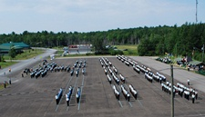
Prior to 1972, Atlantic Region Army Cadet summer training took place in Aldershot, Nova Scotia. In the summer of 1971, it was decided that the Atlantic region army cadet summer training camp would move from Aldershot to Gagetown. In that first summer, 1200 cadets passed through the grounds at Argonaut.
In 1978-79, Argonaut ACSTC saw the addition of main living complexes for the cadets. With these new complexes, Argonaut ACSTC was starting to look more and more permanent. Throughout the 80's, more facilities were added to Argonaut increasing the number of cadets it could train annually. In 1989, Argonaut was given the honour of Freedom of the Town of Oromocto. In 1990, Argonaut was honoured again with another Freedom of the City, this time bestowed by the city of Moncton.
The 1990's saw both the physical size of Argonaut increase as well as the numbers of cadets that were trained here. In 1999, Argonaut received its hardest challenge. Due to Kosovar refugees being relocated on the grounds of Argonaut ACSTC, the training center had to relocate for that summer. Argonaut was divided into three sites, with the majority of cadets being housed at Mount Allison University in Sackville NB while smaller contingents were placed in Port Elgin NB, Slemon Park PEI and even a company in Vernon BC!
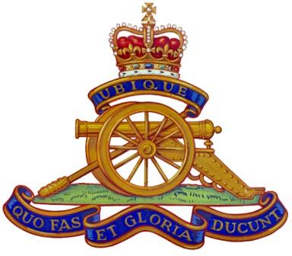
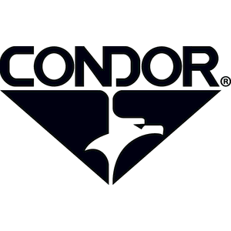
Currently, Argonaut ACSTC has a paved parade square and roads, as well as additional ablution facilities. The most significant change to the training center is the recent addition of the Cadet Dining Hall in 2001. The facility will seat 650 people thus increasing efficiency for meal times.

The training center will have approximately 1000 cadets pass through its gates this summer.

MADE POSSIBLE BY

Your source of top quality bags, boots, hats, and tactical gear. And the artillery cadet program.

Argonaut
Cadet summer camp!

Jaden Belyea. 5/1/2014
Information from http://www.cadets.ca/en/summer-opportunities/training-centres-argonaut.page

